

Design Guide

**MEDICARE**

|  |  |
| --- | --- |
| Faculty Name | Miss. Wajiha Siddiqui |
| Batch Coordinator Name | Miss Warda Siddiqui |
| Batch Code | 2310C2 |
| Group | C |

|  |  |
| --- | --- |
| Enrollment No. | Student Name |
| STUDENT1525023 | IBRAR UL HAQ |
| STUDENT1525014 | M.RAFAY ANWAR |
| STUDENT1523056 | M.ZAID |
| STUDENT1511578 | MUZAMMIL HUSSAIN SOMROO |

**ACKNOWLEDGEMENT**

**We express our sincere gratitude to our faculty “--Miss Wajiha Siddiqui--" and our coordinator for their amazing support and guidance, continuous encouragement and supervision throughout the course of the present work. It’s of no doubt that we have been very fortunate to work under such a supportive and cooperative teacher/coordinator and last but not the least we are extremely grateful to the whole faculty and administration of Aptech, for providing us all the facilities that were mandatory, without which this project could not be a success.**

**SYNOPSIS**

**Konsi languages use kr k banaya ha**

**HTML**

**CSS**

**BOOTSTRAP**

**JAVASCRIPT**

**PHP**

# **PROBLEM DEFINITION & CUSTOMER REQUIREMENT SPECIFICATIONS (CRS)**

**Problem Statement**

We all need to visit doctors some time or the other. Sometimes it is an emergency situation, whereas most of the other time it is a planned checkup/visit. But in both the cases we have to visit the doctor to take an appointment or wait in long queues.

CARE Group is into medical services for long time and looking at the current medical scene have decided to come up with a WEBSITE, which will host the medical services available in different cities.

Individuals will be able to search for specialist doctors in their surroundings and even book online appointments.

Web site should also record the complete information regarding the Doctors and Patients.

**Customer Specifications:**

Website will host information about common Diseases, Preventions and Cures. It will also display the latest medical news and information on inventions in Medical Science.

The website will have three users/roles:

1. Administrator
2. Doctor
3. Patient

The Administrator should be able to do the following:

1. Add Cities to the master database.
2. Add Doctors to the Master database.
3. Modify Doctor Details.
4. Modify Patient Details.
5. Delete Cities
6. Delete Doctors
7. Delete Patients
8. Create/Manage Users/Logins
9. Manage information/details on the WEBSITE

The Doctor should be able to do the following:

1. Login into the system with his USER/PASSWORD
2. View his/her profile details
3. Add details to his/her profile
4. Modify his/her profile
5. View Appointments
6. Update his availability for DAY/WEEK/MONTH

The Patient should be able to do the following:

1. Register/Create Account [USERID should be unique].
2. Search Doctor based on location, Specialist
3. Book Appointment [Check Availability]

# **SCOPE OF THE WORK**

# **Banane ka maqsad?**

**Project Overview:** The Medicare Hospital website will serve as a comprehensive online platform aimed at providing information and resources for patients, caregivers, and healthcare professionals. The site will focus on promoting the hospital's services, facilitating patient engagement, and ensuring compliance with Medicare guidelines.

**Objectives:**

1. **Information Dissemination:** Provide clear and accessible information about the hospital’s services, specialties, and staff.
2. **Patient Engagement:** Enable patients to access their medical records, schedule appointments, and communicate with healthcare providers.
3. **Compliance and Education:** Offer resources on Medicare coverage, benefits, and eligibility, including FAQs and educational materials.
4. **Community Outreach:** Highlight community health initiatives, events, and partnerships with local organizations.

**Key Features:**

* **User-Friendly Navigation:** Intuitive layout for easy access to information.
* **Patient Portal:** Secure access for patients to manage appointments, view test results, and communicate with doctors.
* **Educational Resources:** Articles, videos, and FAQs on Medicare and hospital services.
* **Responsive Design:** Optimized for mobile devices to accommodate all users.
* **Contact Information:** Easy access to contact details for various departments and support services.

**Target Audience:**

* Medicare beneficiaries
* Patients and their families
* Healthcare providers
* Community members seeking health information

**Technical Requirements:**

* Compliance with ADA and WCAG standards for accessibility.
* Integration with existing hospital management systems for seamless patient interaction.
* Secure hosting and data protection measures to ensure patient confidentiality.

**Timeline:**

* Initial development: 6 months
* Testing and feedback phase: 2 months
* Launch and promotion: 1 month

# 

# **Entity Relationship Diagram**

# 

# **SCREENSHOTS**

Front end screenshots

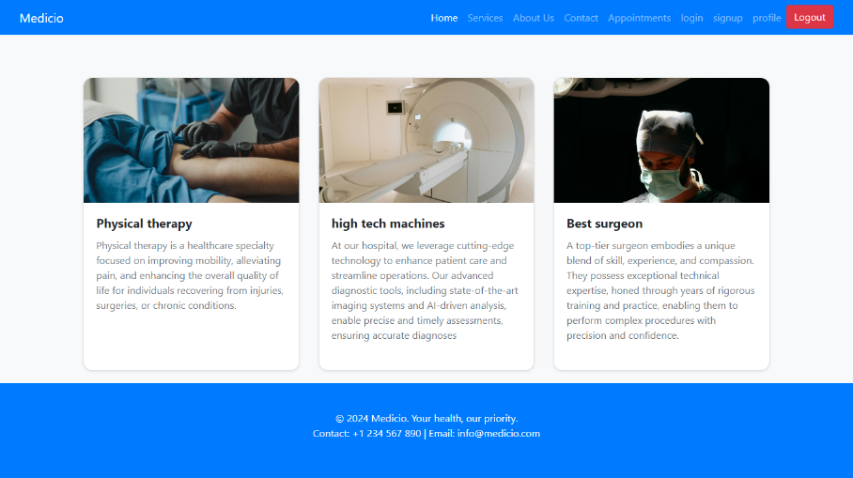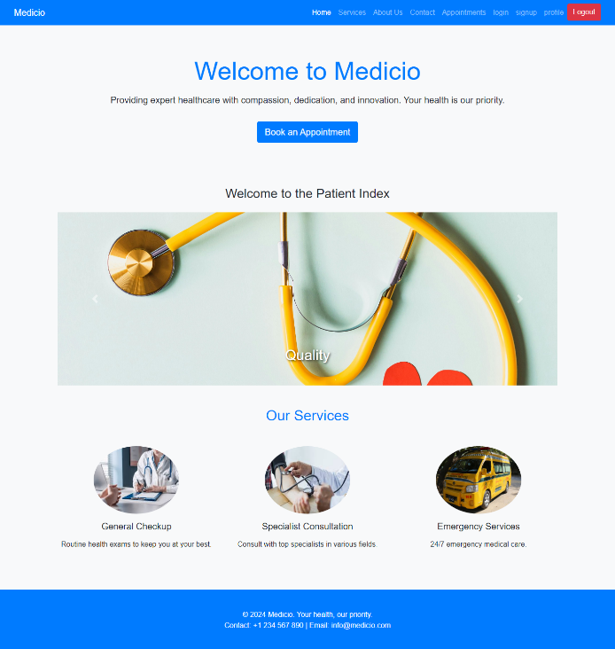

**SERVICES PAGE**

**Home PAGE**

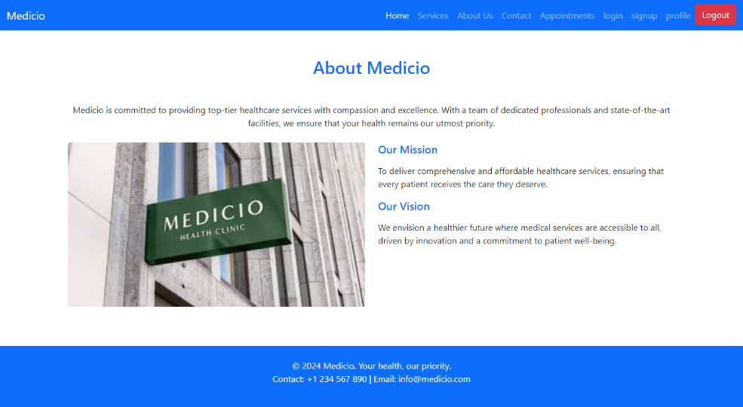

**ABOUT US PAGE**

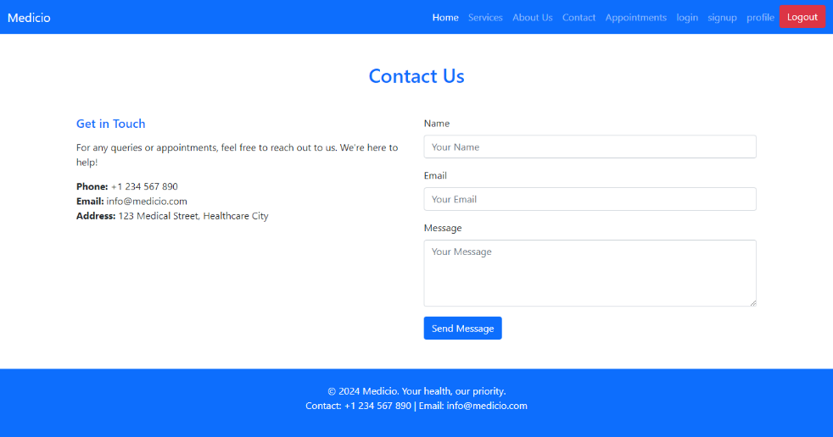

**CONTACT US PAGE**

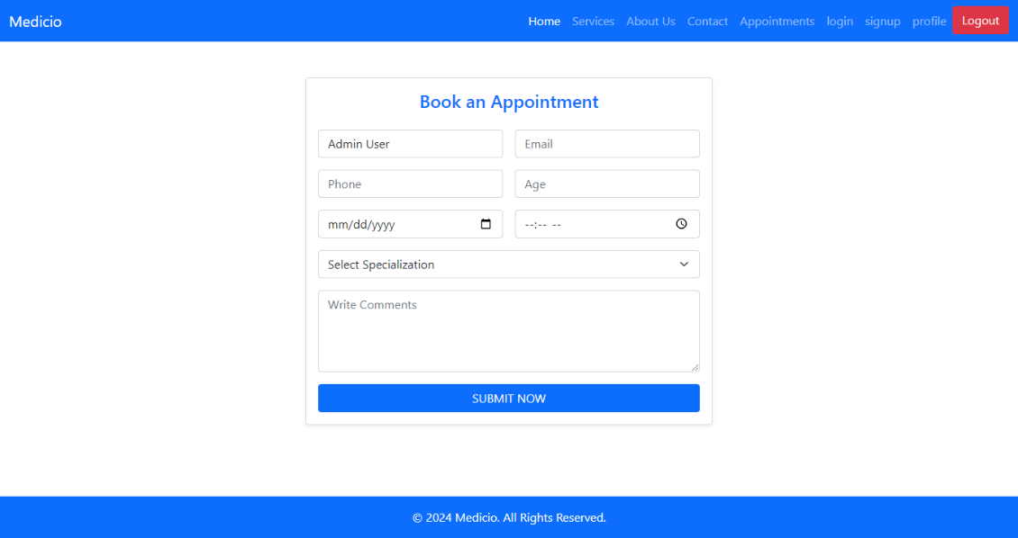

**APPOINTMENT PAGE**

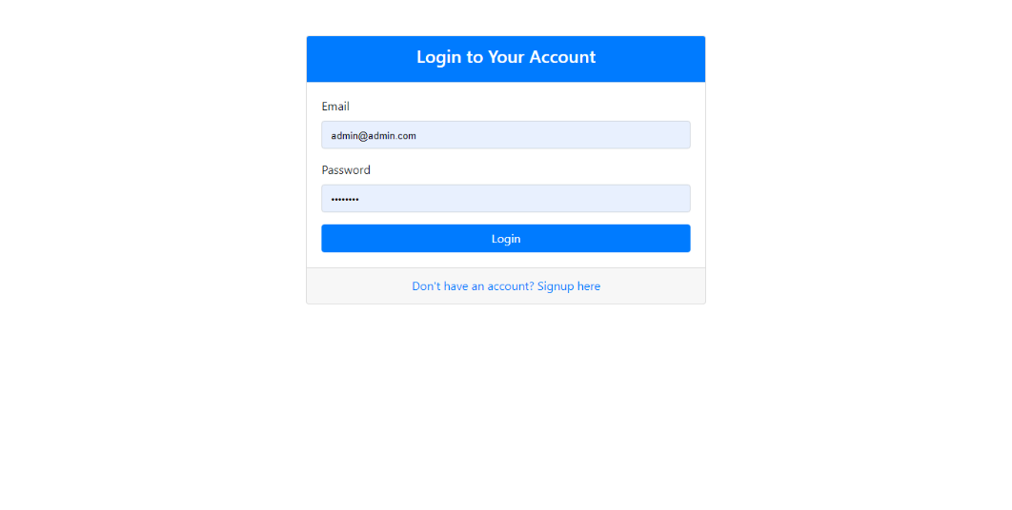

**LOGIN PAGE**

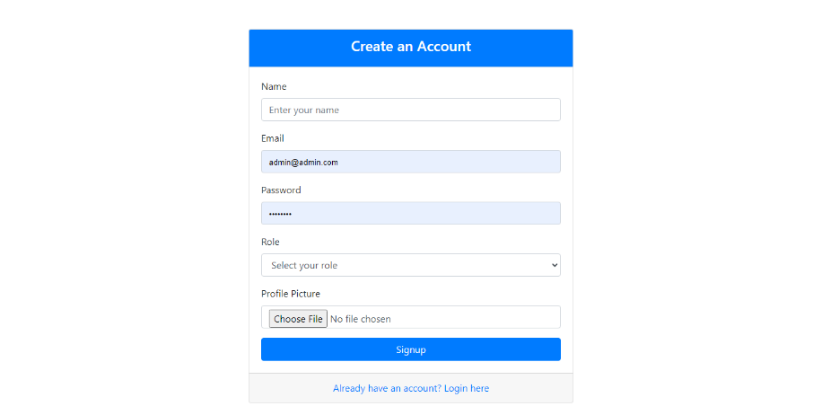

**SINGUP PAGE**

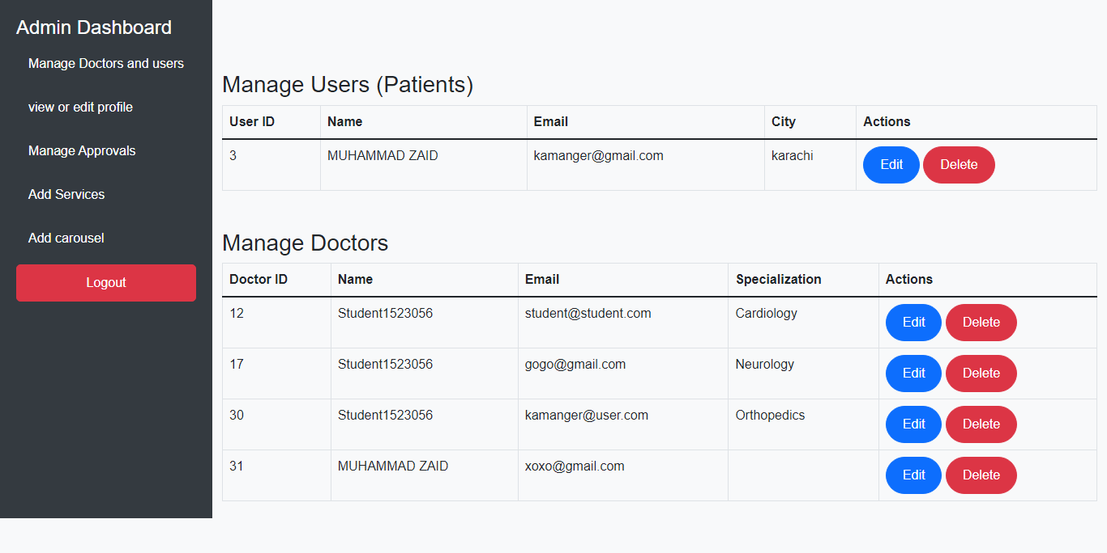

**ADMIN DASHBOARD PAGE**

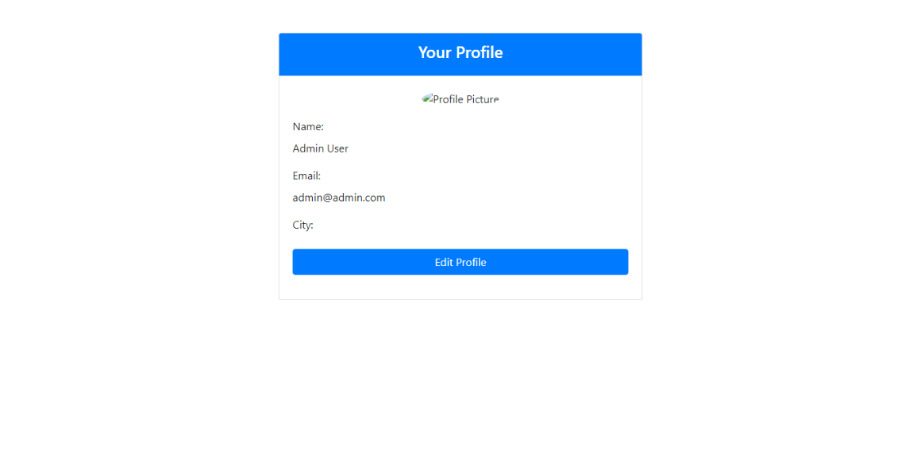

**EDIT PROFILE PAGE**

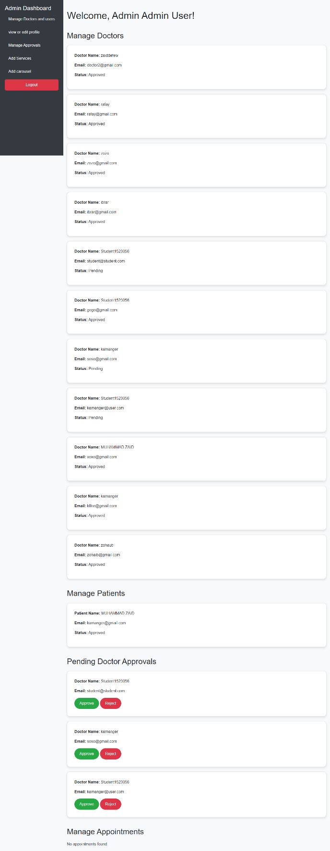

**APPROVE REJECT PAGE**

**FOR DOCOTOR SINGUP PAGE**

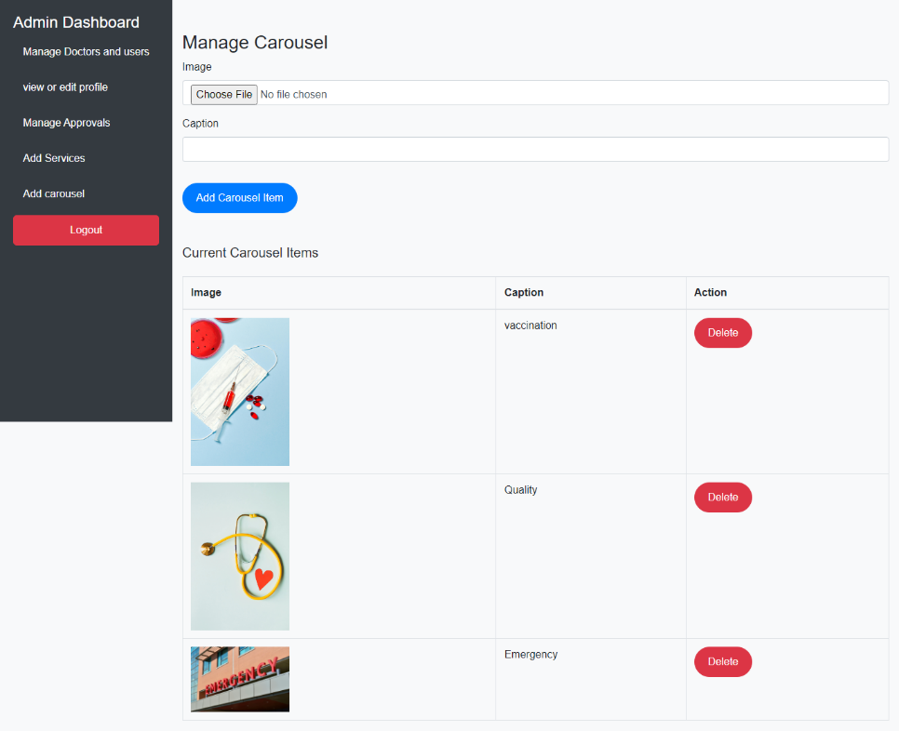

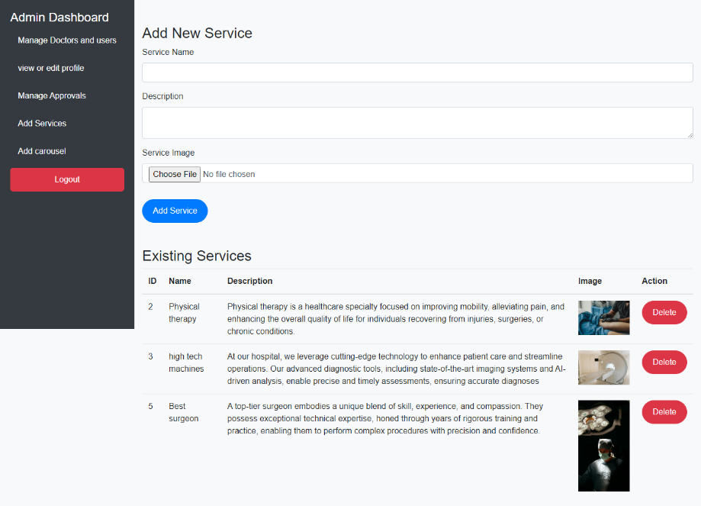

**ADD CAROUSEL PAGE**

**ADD SERVICES PAGE**

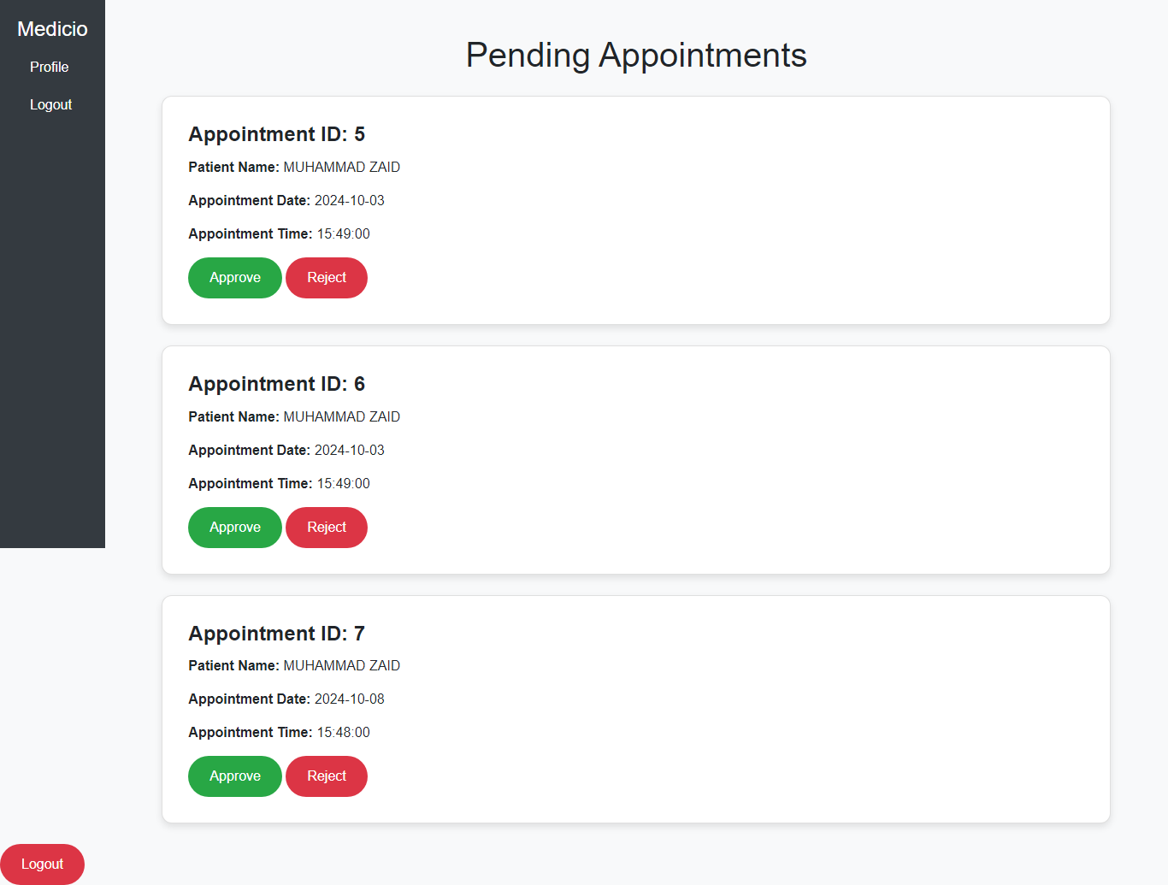

**Appointment approve or reject by doctor PAGE**